IT 511: Object Oriented Application Development
Module Six: Classes
ZyBooks: Programming in Java: Early Objects
Chapters 9 & 10
4/25/22

Learning Objectives

- Recognize the role of methods in accessing and modifying data in classes
- Write methods for a collection class for a collection manager program
- Write methods for an item class for a collection manager program

Textbook Sections

Chapter 9: Methods Continued
- 9.1 Methods With Branches/Loops
- 9.2 Unit Testing (Methods)
- 9.3 How Methods Work
- 9.4 Methods: Common Errors
Chapter 10: Classes Continued
- 10.1 Mutators, Accessors and Private Helpers
- 10.2 Constructors
- 10.3 Constructor Overloading

Module Overview

You have reached Module Six. You are halfway through your introduction to object-oriented programming in this course. This is a great time to review the Final Project Guidelines and Rubric document to make sure you understand all the requirements of the final project. In this module, you will continue to build the skills you need to develop a collection manager program through a consideration of the object-oriented concept of class.
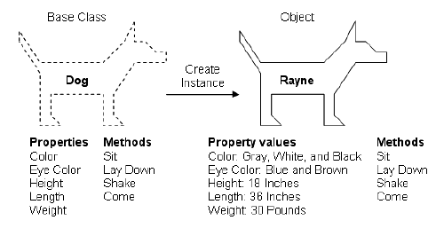
Image 6.1: Zak Ruvalcaba, “Build Your Own ASP.NET Website Using C# and VB.NET”
(Image source: SitePoint)
As this diagram shows, a class may be used to create a number of instances united by common properties and methods.
As you may recall, a class may be considered a category that holds similar objects. More precisely, however, it is a coding template that allows for the creation of objects with common attributes or properties that act through common methods. The figure above illustrates the concept of class and its relation to objects. In this case, “dog” is the class and a particular dog, Rayne, is an object with distinct values that also fulfills the common attributes and methods of the class. As you work with the zyBooks materials in this module, keep a simple image of the concept of class in mind as your consider how classes may be accessed or change through public methods or how the members of a class may be initialized by a constructor.
In this module, you will complete the fifth stepping stone lab in which you will construct a collection manager class then an item class, each modified by methods including getters and setters, also known as accessors and mutators. Mutators, or setters, and accessors, or getters, are used to enact encapsulation, as instance variables in a class separate the data from the methods that access and modify that data.
A similar type of structure and functionality will be instrumental in developing the collection manager program in your final project. Be sure to note any ideas you have that may help with your final project as you work through the tasks in Module Six.

